AI ASSISTED CODING
LAB Assignment 2.3
RAVULA VIDYA SRI
BT-31
CSE-AIML
2303A52014

Task 1: Word Frequency from Text File
❖ Scenario:
You are analyzing log files for keyword frequency.
❖ Task:
Use Gemini to generate Python code that reads a text file and counts word
frequency, then explains the code.

Prompt:-
Generate a Simple python program that reads a text file e.g, fruits counts the frequency of each word, and displays the result

Code:-
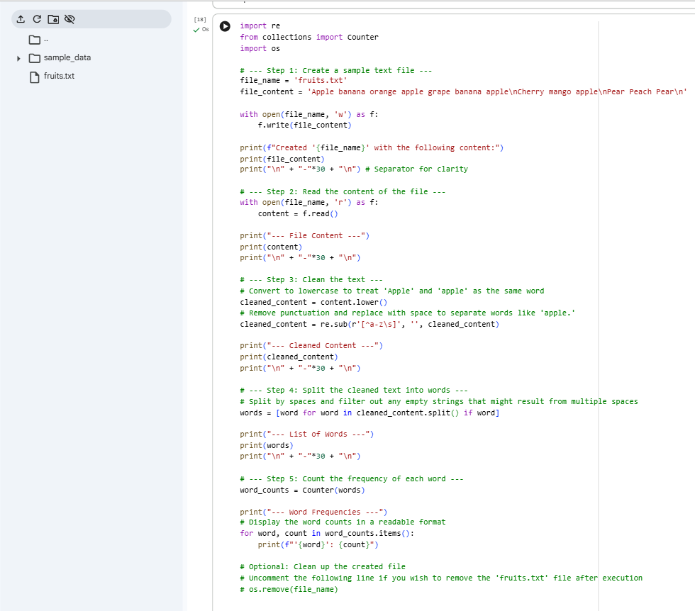

Output:-
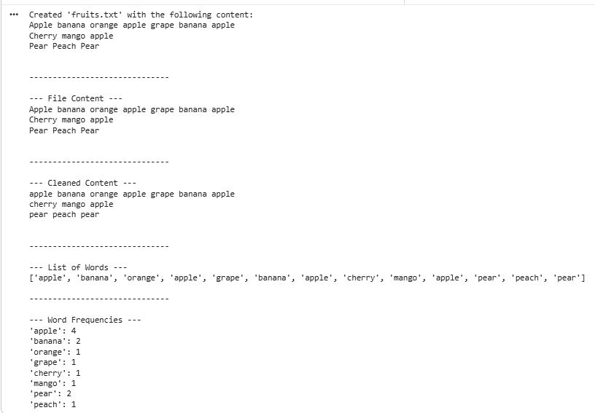

Explanation:-
We created a sample fruits.txt file with text content.
The program read this file, then converted its text to lowercase and removed punctuation.
It then split the cleaned text into individual words.
Using collections. Counter, it calculated the frequency of each unique word.
Finally, it displayed the count for every word found in the file.
Task 2: File Operations Using Cursor AI
❖ Scenario:
You are automating basic file operations.
❖ Task:
Use Cursor AI to generate a program that:
➢ Creates a text file
➢ Writes sample text
➢ Reads and displays the content
Prompt:-
Generate a simple python that creates a text file write sample text into it e.g., fruits, then reads and display the content.
Code:-
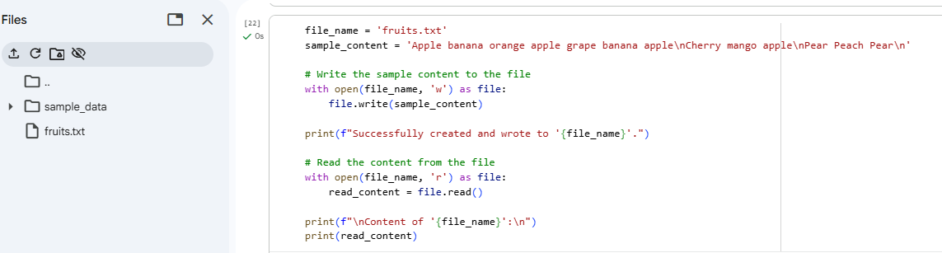
Output:-
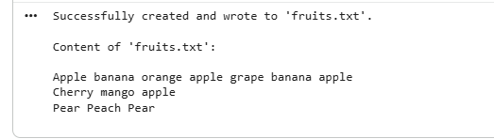
Explanation:- The program first defines the file name (fruits.txt) and the sample content.
It then opens the file in write mode ('w').
The sample content is written into the fruits.txt file.
Next, the file is opened again in read mode ('r').
Finally, the file content is read and printed on the console.

Task 3: CSV Data Analysis
❖ Scenario:
You are processing structured data from a CSV file.
❖ Task:
Use Gemini in Colab to read a CSV file and calculate mean, min, and max.
Prompt:-
Generate a simple python program using pandas to read a CSV file and calculate the mean, minimum and maximum values. Explain the code clearly.
Code:-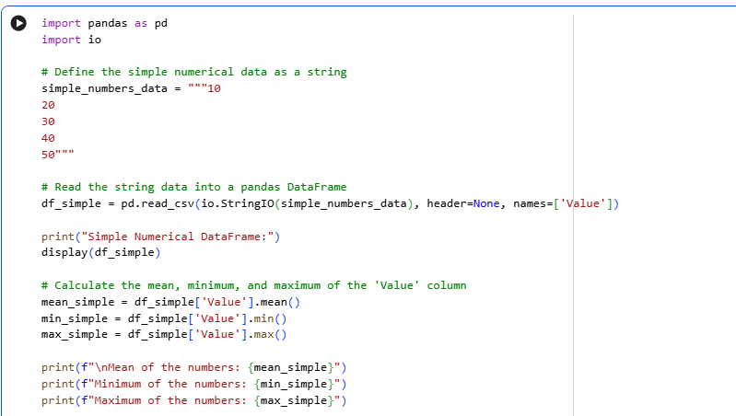

Output:-
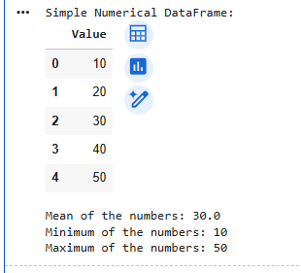
Explanation:-
- The program imports the pandas library.
- It reads the CSV file using read_csv().
- The mean, minimum, and maximum values are calculated.
- These calculations are done on the Values column.
- The results are printed to the console.
Task 4: Sorting Lists – Manual vs Built-in
❖ Scenario:
You are reviewing algorithm choices for efficiency.
❖ Task:
Use Gemini to generate:
➢ Bubble sort
➢ Python’s built-in sort()
➢ Compare both implementations.
Prompt:-
Generate Python code for bubble sort and Python’s built-in sort().
Explain the difference between them in simple terms.

Code:-
Manual sort-
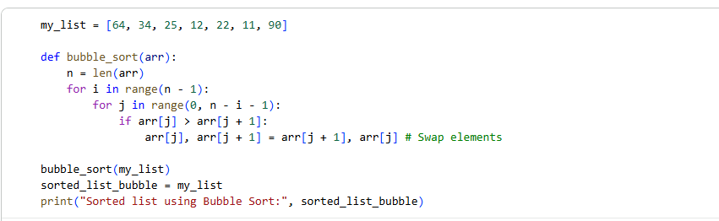
Output:-
Built-in Sort:-
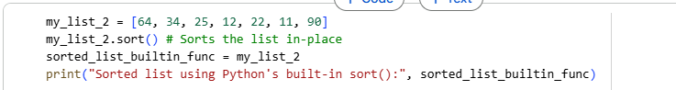
Output:-
Explanation :-Bubble Sort is a basic sorting algorithm that compares and swaps adjacent elements.
It is easy to understand and implement.
However, it is very slow for large datasets with time complexity O(n²).
Python’s built-in sort() uses an optimized algorithm called Timsort.
It is much faster and efficient with average time complexity O(n log n).

